**ST.XAVIER’S COLLEGE**

MAITIGHAR, KATHMANDU



**Database Management System**

Assignment #1

Submitted By:

Aashish Raj Shrestha

013BSCCSIT002

2nd year/ 4th semester

Submitted to:

|  |  |
| --- | --- |
| Er. Anil Shah  Lecturer  Department of Computer Science |  |

1. **Statement:**

Draw the following check box:

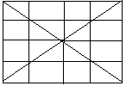

1. **Source Code:**

//---------------------------------------------------------------------------

#include <vcl\vcl.h>

#pragma hdrstop

#include "Checkbox.h"

//---------------------------------------------------------------------------

#pragma resource "*.dfm"

TForm1 *Form1;

//---------------------------------------------------------------------------

__fastcall TForm1::TForm1(TComponent* Owner)

: TForm(Owner)

{

}

//---------------------------------------------------------------------------

void __fastcall TForm1::Button1Click(TObject *Sender)

{

Image1->Canvas->MoveTo(0,0);

Image1->Canvas->LineTo(0,100);

Image1->Canvas->LineTo(100,100);

Image1->Canvas->LineTo(100,0);

Image1->Canvas->LineTo(0,0);

Image1->Canvas->MoveTo(25,0);

Image1->Canvas->LineTo(25,100);

Image1->Canvas->MoveTo(50,0);

Image1->Canvas->LineTo(50,100);

Image1->Canvas->MoveTo(75,0);

Image1->Canvas->LineTo(75,100);

Image1->Canvas->MoveTo(0,25);

Image1->Canvas->LineTo(100,25);

Image1->Canvas->MoveTo(0,50);

Image1->Canvas->LineTo(100,50);

Image1->Canvas->MoveTo(0,75);

Image1->Canvas->LineTo(100,75);

Image1->Canvas->MoveTo(0,0);

Image1->Canvas->LineTo(100,100);

Image1->Canvas->MoveTo(0,100);

Image1->Canvas->LineTo(100,0);

}

//---------------------------------------------------------------------------

1. **Output:**

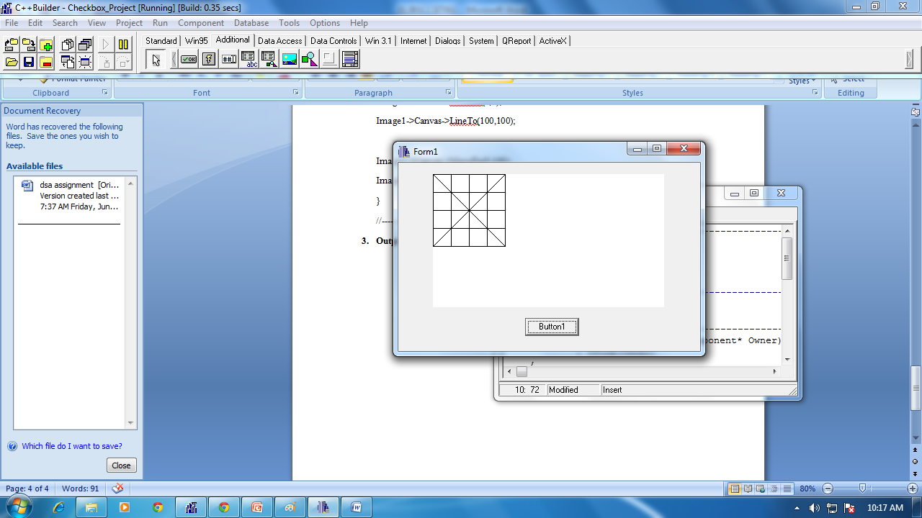

*Figure I: Screenshot of Output Checkbox*